AP Chemistry Thermodynamics Free Response Practice

1. (a) State the physical significance of entropy.
(b) From each of the following pairs of substances, choose the one expected to have the greater absolute entropy. Explain your choice in each case. Assume 1 mole of each substance.
(1) Pb(s) or C(graphite) at the same temperature and pressure
(2) He(g) at 1 atmosphere or He(g) at 0.05 atmosphere, both at the same temperature
(3) H₂O(l) or CH₃CH₂OH(l) at the same temperature and pressure
(4) Mg(s) at 0 °C or Mg(s) at 150 °C, both at the same pressure.
2.
Substance | Enthalpy of Combustion  ΔH° Kilojoules/mole | Absolute Entropy, S°  Joules/mole-K
C(s) | - 393.5 | 5.740
H₂(g) | - 285.8 | 130.6
C₂H₅OH(l) | - 1366.7 | 160.7
H₂O(l) | ------------ | 69.91

(a) Write a balanced chemical equation for the combustion of each of the following: C(s), H₂(g), and C₂H₅OH(l). Consider the only products to be CO₂(g) and/or H₂O(l).

(b) In principle, ethanol can be prepared by the following reaction.

2 C(s) + 2 H₂(g) + H₂O(l) --> C₂H₅OH(l)
Calculate the standard enthalpy change, ΔH°, for the preparation of ethanol, as shown in the reaction above.

(c) Calculate the standard entropy change, ΔS°, for the reaction given in part (b)

3.
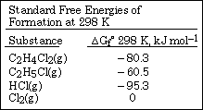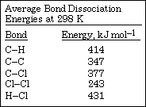

The tables above contain information for determining thermodynamic properties of the reaction below.

C₂H₅Cl(g) + Cl₂(g) <===> C₂H₄Cl₂ (g) + HCl(g)
(a) Calculate ΔH° for the reaction above, using the table of average bond dissociation energies.

(b) Calculate ΔS° for the reaction at 298 K, using data from either table as needed.

4. A student performs an experiment to determine the molar enthalpy of solution of urea, H2NCONH2. The student places 91.95 g of water at 25°C into a coffee-cup calorimeter and immerses a thermometer in the water. After 50 s, the student adds 5.13 g of solid urea, also at 25°C, to the water and measures the temperature of the solution as the urea dissolves. A plot of the temperature data is shown in the graph below.

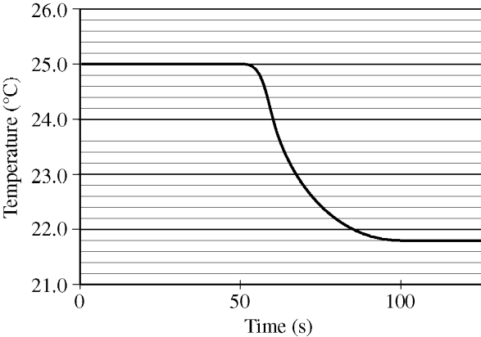
Determine the change in temperature of the solution that results from the dissolution of the urea.
(b) According to the data, is the dissolution of urea in water an endothermic process or an exothermic process?
Justify your answer.
(c) Assume that the specific heat capacity of the calorimeter is negligible and that the specific heat capacity of the solution of urea and water is 4.2 J g-1 °C-1 throughout the experiment.
(i) Calculate the heat of dissolution of the urea in joules.
(ii) Calculate the molar enthalpy of solution, ∆Hsoln , of urea in kJ/ mol.

